**Name : Paula Ayman Mikhael Boktur الاسم : بولا أيمن ميخائيل بقطر**

**B.N : 258 رقم الجلوس : 258**

**Date : 5/6/2021**

**Subject : Computer**

**Topic : Computer Engineering Role in COVID-19**

**-------------------------------------------------------------------------------------------**

Topic and application brief :

Thanks to computer engineering, it is now easy to know all the information and everything new about the Corona virus pandemic, such as the number of daily recovery or injuries in all countries, and also because of this, education and study continued because it is only allowed from a distance without gatherings.

Source code :

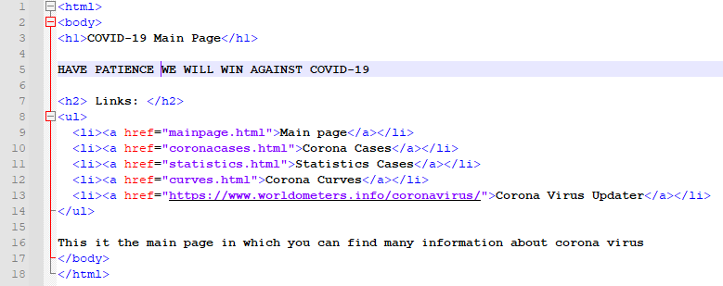

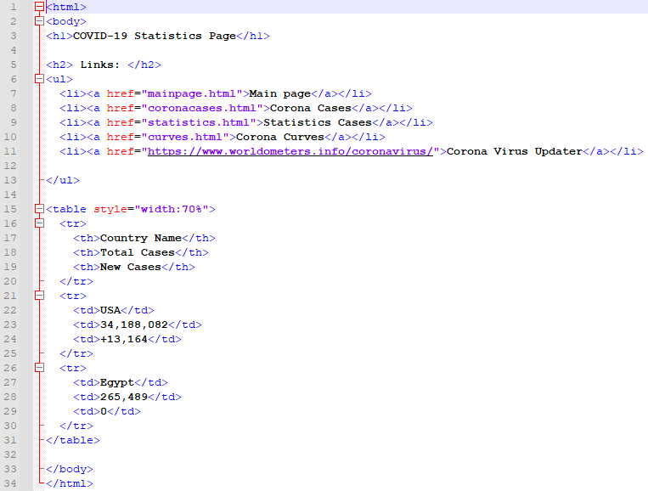

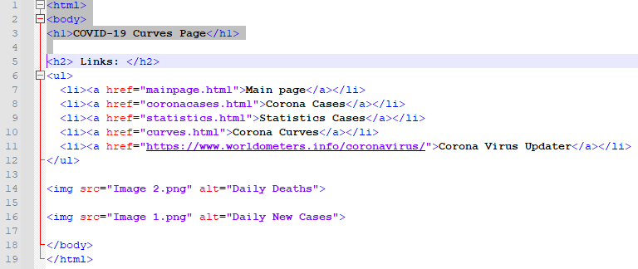

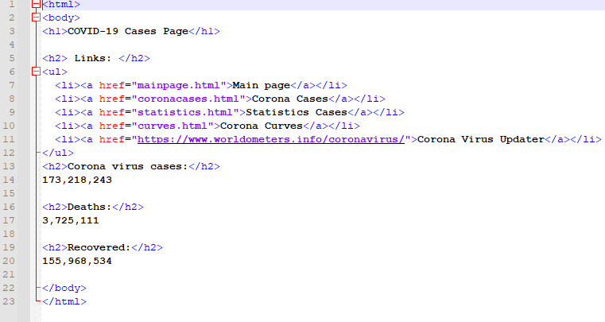

Screenhots :



